BETTER QUESTION FOR QUESTIONAIRE
Pearson Edexcel - Thursday 26 May 2016 - Paper 1 (Non-Calculator) Higher Tier
1.
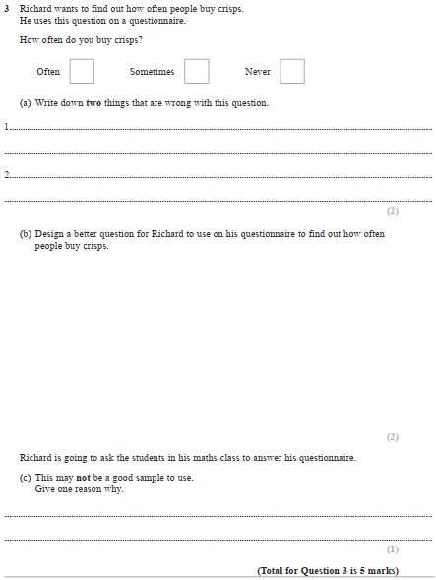
Pearson Edexcel - Wednesday 4 November 2015 - Paper 1 (Non-Calculator) Higher Tier
2.
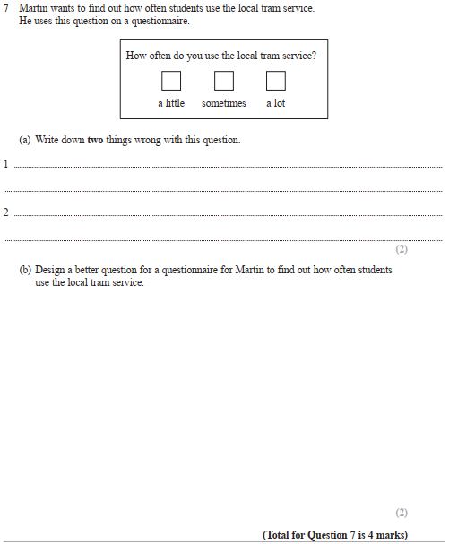
Pearson Edexcel - Thursday 4 June 2015 - Paper 1 (Non-Calculator) Higher Tier
3.
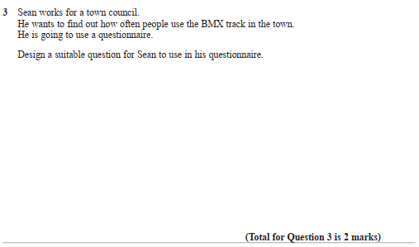
Pearson Edexcel - Wednesday 5 November 2014 - Paper 1 (Non-Calculator) Higher Tier
4.
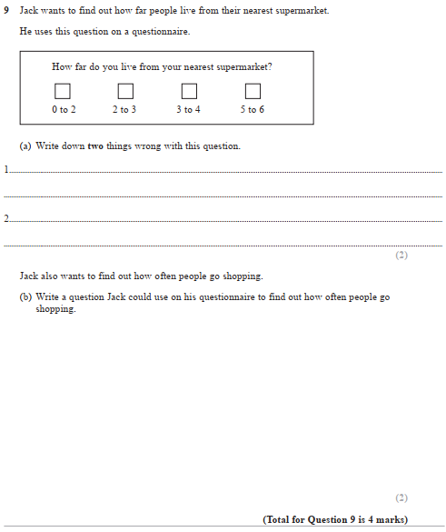
Pearson Edexcel - Monday 9 June 2014 - Paper 1 (Non-Calculator) Higher Tier
5.
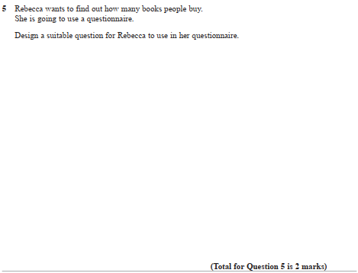

Pearson Edexcel - Wednesday 6 November 2013 - Paper 1 (Non-Calculator) Higher Tier
6.
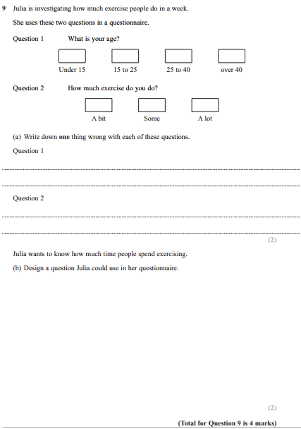
Pearson Edexcel - Friday 14 June 2013 - Paper 2 (Calculator) Higher Tier
7.
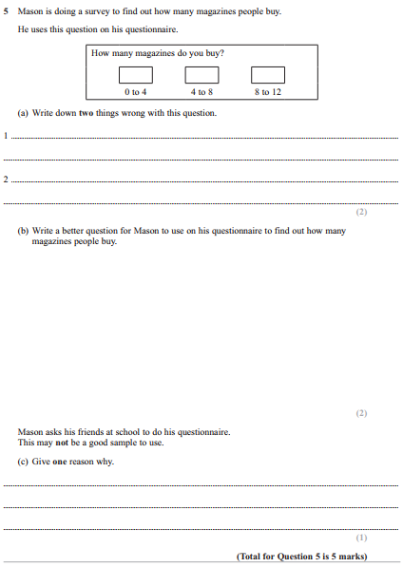

Pearson Edexcel - Thursday 28 February 2013 - Paper 1 (Non-Calculator) Higher Tier
8.
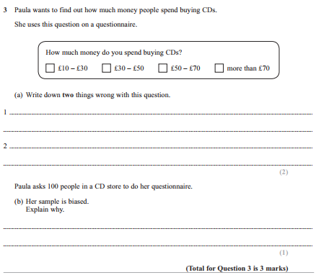

Pearson Edexcel - Tuesday 6 November 2012 - Paper 1 (Non-Calculator) Higher Tier
9.
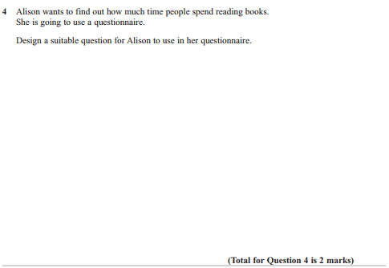
Pearson Edexcel - Wednesday 13 June 2012 - Paper 2 (Calculator) Higher Tier
10.
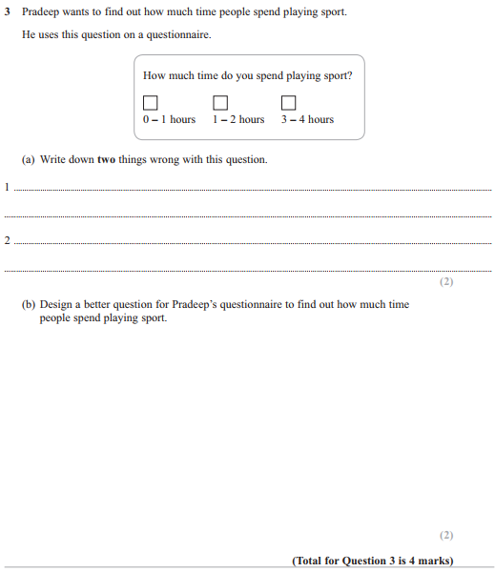

Pearson Edexcel - Monday 14 November 2011 - Paper 4 (Calculator) Higher Tier
11.

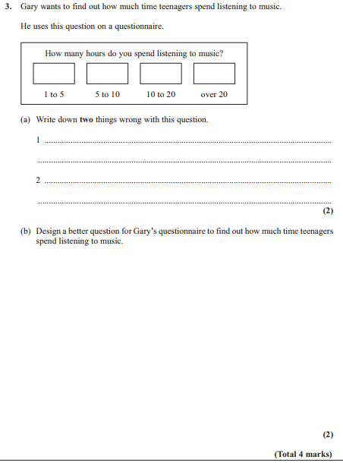

Pearson Edexcel - Monday 6 June 2011 - Paper 3 (Non-Calculator) Higher Tier
12.
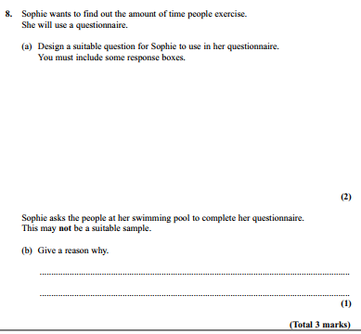

Pearson Edexcel - Friday 12 November 2010 - Paper 4 (Calculator) Higher Tier
13.
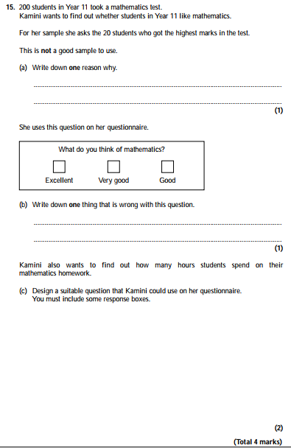

Pearson Edexcel - Monday 7 June 2010 - Paper 3 (Non-Calculator) Higher Tier
14.
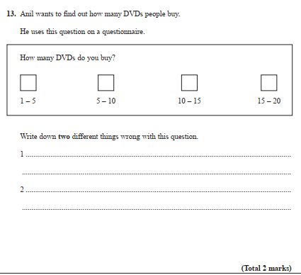
Pearson Edexcel - Thursday 5 November 2009 - Paper 3 (Non-Calculator) Higher Tier
15.
